Algebra 3-4 Name: ______________________
Quiz 2.1-2.4 Block: _____

Identify the domain and range. Then tell whether the relation is a function.
Input Output
1. {(3, 2), (-2, 5), (1, 0), (-4, 6), (1, -1)} 2.
-5 -3
0
4 2
8 6

domain: ___________ domain: _________

range: ____________ range: ___________

function: yes or no function: yes or no

Tell whether the relation is a function. Explain your reasoning.
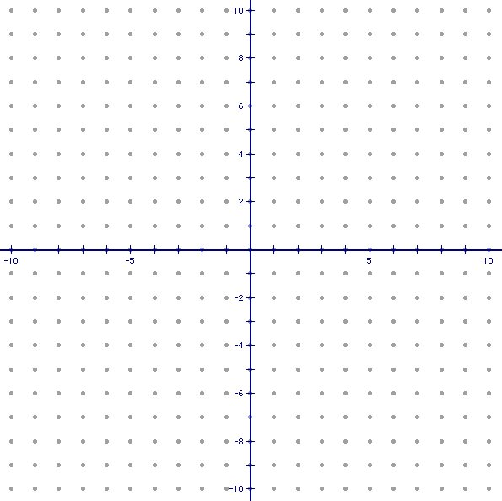
3.

Decided whether the given function is linear, then evaluate it for the given value of x.

4. 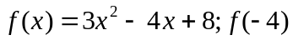

Find the slope of the line through the given points. Then write the equation for the line.

5. (-4, 6) and (-2, 5) 6. (3, -4) and (-2, -4)

Write the Equation in Slope-Intercept Form.

8. -3x+2y=7

Graph the following equations.

9. y = -2x + 6 10. x = -3

Identify the intercepts.

12. 2x + 5y = 10

x-intercept: ___________ y-intercept: ___________

Find what is needed.

13. One day your family goes out to pick strawberries. At 9:00am, your family has picked 3 quarts. Your family finishes picking at 3:00pm and has 28 quarts of strawberries, stopping only 1 hour for lunch. At what rate was your family picking strawberries?

